MAC Block Automation Tool
Use Case :
Using this tool user can add the library components (FB, FC, DB, etc.) to the TIA Portal project and provide a user interface that allows users to define and update the block calling structure and interface tags for the called blocks. Additionally, it enables updating existing project for block calling and tag assignment.Technology:
- C# (.NET Framework)
- Siemens TIA Portal Openness Version 20.
- WPF (UI)
- CSV + XML Processing
Purpose:
Instead of manually creating PLC logic networks in TIA, the user can:
- Define block calls in UI
- Generate CSV
- Automatically create networks and instance DBs in TIA
Project Structure :
Your solution contains the following major components:
GeneratedClasses
Auto-generated PLC block classes.
Examples:
Block_1.cs
Block_2.cs
TestLibrary.cs
These represent PLC blocks from the TIA library.

Core Logic Files
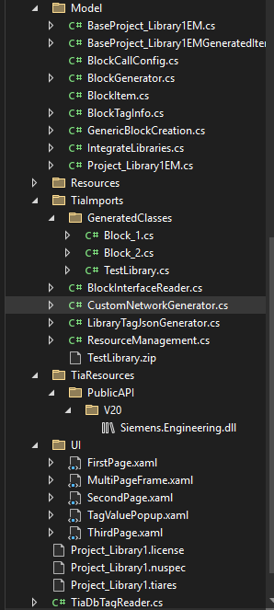
These files handle:
- Block interface reading
- Network generation
- JSON generation
- PLC resource integration
Flow of Project :
- Needs to create PLC logic like:
- OB (Main program)
- FC (Function call)
- FB (Function block with Instance DB)
- Tag connections
Normally, this is done manually in TIA Portal
- MAC tool allows:
  - In MAC Application user first create project based on TIA Portal then give path of .ap Project of TIA Project.
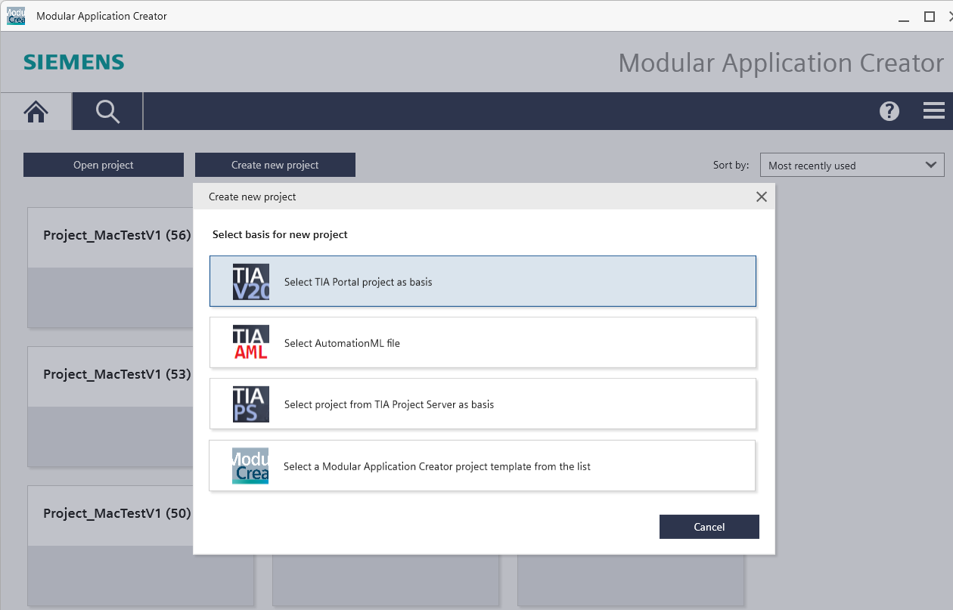
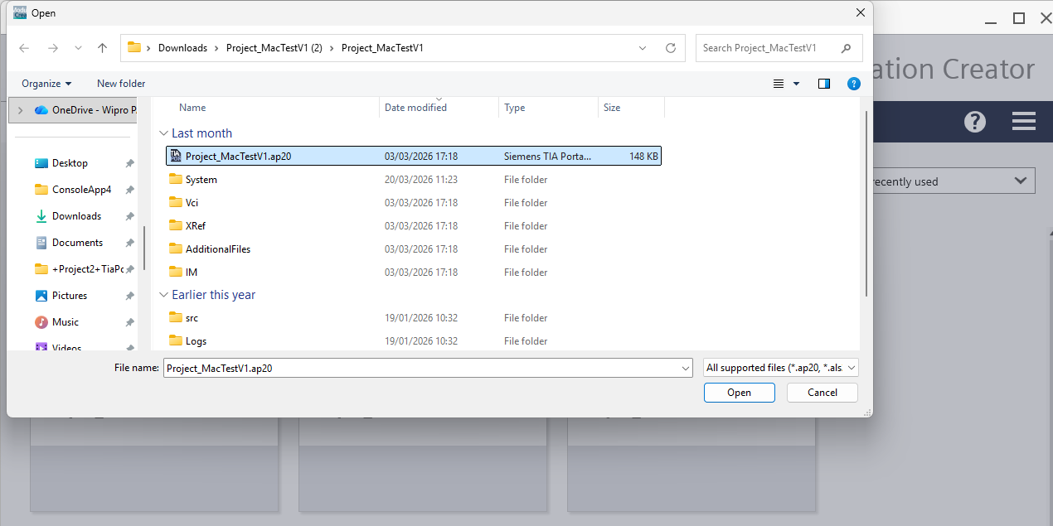
  - Then We will Drag and Drop Module on Select Modules Page, after successfully creating module we select it and goes on next page which is Configure Modules.
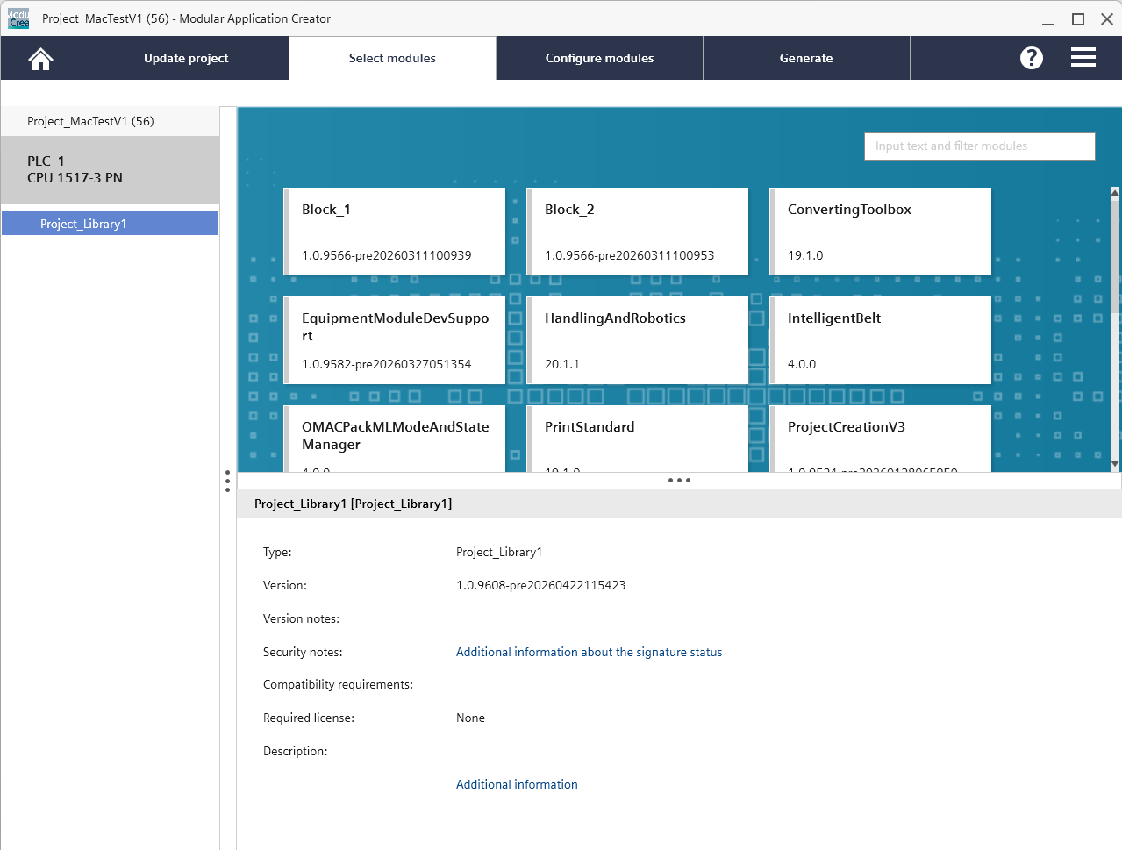
  - Three pages present on Configure Modules
First Page
Purpose:
Allows the user to select blocks from the TestLibrary_Blocks.
Features:
- Displays available PLC blocks
- User selects blocks for automation
- Selected blocks move to configuration stage
First Page – Add Library Blocks into TIA Project
Feature: Add Library Block into TIA Project
(Checkbox)
A checkbox option is provided on the First Page of the MAC tool to allow the user to control whether Add Library Block into TIA Project
Checkbox Label
Add Library Block into TIA Project(SkipBlock Calling)
Purpose of the Checkbox
This option enables a Add Library Block into TIA Project where the user can work with block configuration and tag mapping without generating PLC logic in TIA Portal.
This is useful for:
- Testing block interfaces
- Generating JSON configuration
- Validating tag assignments
- Demonstrating the tool without modifying the PLC project
Behavior of the Checkbox
When Checkbox is Checked
If the checkbox is enabled:
- The system does not execute Block Calling.
- The following function is skipped:
GenerateOBWithMultipleCalls()
Instead, the tool operates only Add Library Block into TIA Project.
Message shown:
Started Add Library Block into TIA Project.
Block Calling skipped.
When Checkbox is Unchecked
- The system runs the full MAC generation process.
- PLC program structures are automatically created inside TIA Portal.
The following actions occur:
- Read CSV configuration files
- Generate OB networks
- Create FB / FC block calls
- Create Instance Data Blocks
- Connect input/output tags
The main method executed:
GenerateOBWithMultipleCalls()
Result:
PLC logic is generated inside the TIA Portal project.
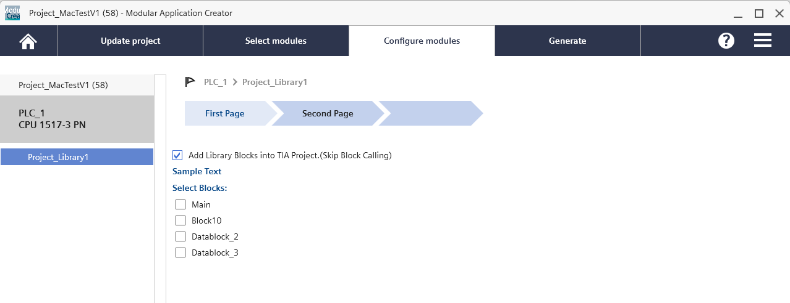
Second Page
Purpose:
Generates the BlockTags.json file.
Button:
Generate BlockTags.json
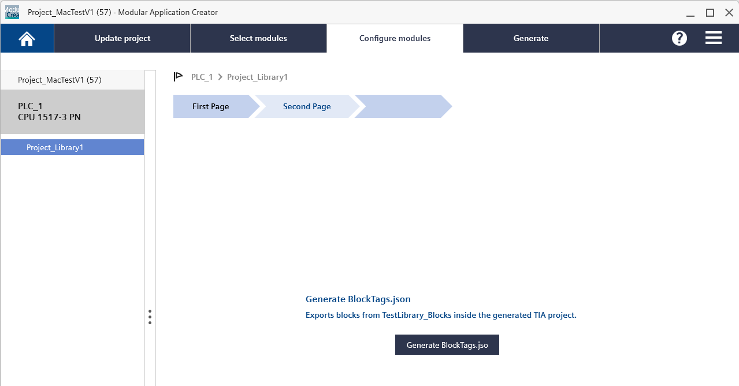
Functionality:
Example JSON:
{
"Block_1": {
"Inputs": {
"Input1": "Int",
"Input2": "Int"
},
"Outputs": {
"Output1": "Int",
"Output2": "Int"
}
}
}

The system reads block interfaces from the TIA project and exports them into a JSON structure.
Purpose of JSON:
- Stores block interface structure
- Used later to validate tags
- Provides datatype mapping
Output file:
C:\MACOP\Export\BlockTags.json
Third Page
Purpose:
Create the block call structure.
Features:
- TreeView block structure
- Parent-child block relationships
- Network number configuration
- Instance DB assignment

Example structure:
Main OB
└ DummyFC
├ Block_1 (Network 1)
├ Block_2 (Network 3)
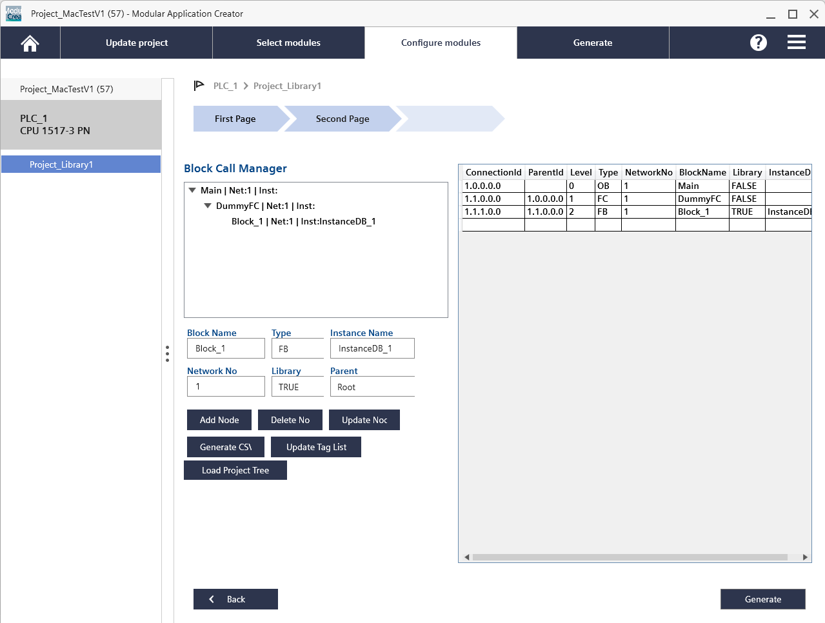
TagValuePopup Page
Purpose:
Allows the user to assign actual PLC tag values to block parameters.
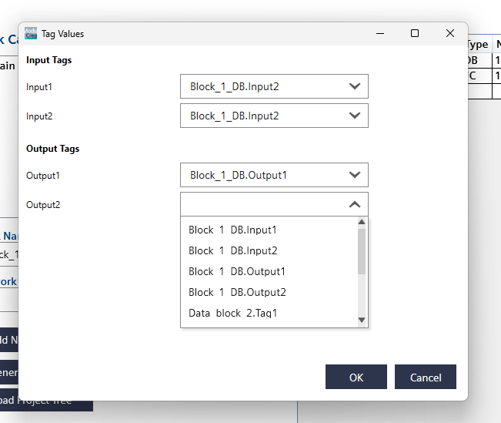
Connection ID Logic
Connection IDs represent hierarchy.
Example:
1.3.8.0.0
Meaning:
1 → OB network
3 → FC network
8 → FB network
0 → reserved
0 → reserved
This ensures proper block hierarchy generation.
CSV Generation
Once configuration is completed, click on Generate CSV button the tool generates CSV files.
ProgramBlock.csv
Defines program hierarchy.
Example:
ConnectionId,BlockName,InstanceDB
1.0.0.0.0,Main,
1.1.0.0.0,DummyFC,
1.1.1.0.0,Block_1,InstanceDB_1
Interface.csv
Defines connections.
Example:
ConnectionId,BlockName,InstanceDB,InputTag,OutputTag
1.1.1.0.0,Block_1,InstanceDB_1,Data_block_2.Tag1,Data_block_3.Output1
Generation Engine
Main method:
GenerateOBWithMultipleCalls()
Responsibilities:
- Read CSV files
- Parse block hierarchy
- Create PLC networks
- Create instance DBs
- Connect input/output tags
TIA Portal Automation
Using TIA Portal Openness API, the system performs:
- OB creation
- Network creation according to user Provided Network Number
- FB / FC calls
- Instance DB creation
- Tag connections

Result in TIA Portal:
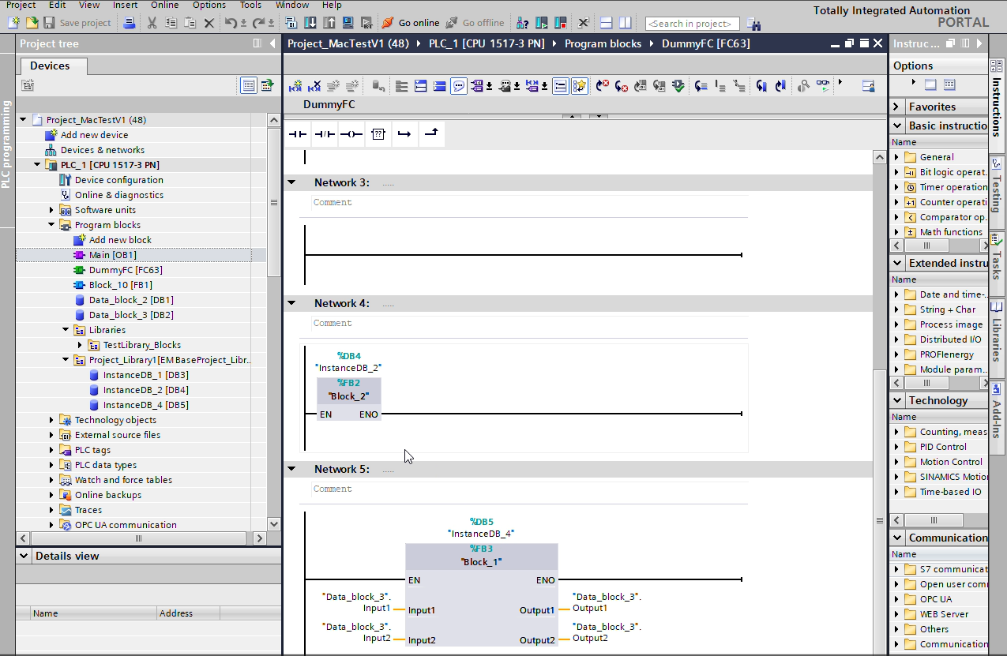

All Methods Used in C # Programming with Descriptions
First Page – Block Selection Page
Method: ChkTestLibrary_Checked() : This Method Present in FirstPage.xaml.cs
Purpose
It will Add Test Library in TIA Project and skip Block Calling.
Function
Sets SkipTiaGeneration = true
Method: ChkTestLibrary_Unchecked() : This Method Present in FirstPage.xaml.cs
Purpose
Generate TIA Project With Block Calling Based on Test Library Blocks.
Function
Sets SkipTiaGeneration = false
Second Page – Generate Block Interface JSON
Purpose
Exports block interfaces from TestLibrary_Blocks and generates a JSON file containing:
- Block name
- Input parameters
- Output parameters
- Data types
Button: Generate BlockTags.json
Purpose
Reads block interfaces from the library and exports them into a JSON file.
Output File
C:\MACOP\Export\BlockTags.json
Method: GenerateBlockTagsJsonFromMacProject () : This Method Present in LibraryTagJsonGenerator.cs class
Purpose
Generates the BlockTags.json file.
Description
Steps performed:
- Reads blocks from TestLibrary_Blocks
- Extracts interface parameters
- Reads datatype information
- Builds JSON structure
- Writes JSON file

Example JSON Structure
{
"Block_1": {
"Inputs": {
"Input1": "Int",
"Input2": "Int"
},
"Outputs": {
"Output1": "Int",
"Output2": "Int"
}
}
}
Third Page – Block Call Manager
Purpose
Allows the user to build the PLC block call structure.
This page contains:
- TreeView block hierarchy
- Table showing connection IDs
- Block configuration controls
Button: Add Node
Purpose
Adds a new block to the Tree structure if this block have Input and Output tags then it will open popup to provide values.
Method
AddNode_Click()
Description
Creates a new node in the TreeView containing:
- Block name
- Network number
- Instance DB
- Parent block
TagValuePopup – Assign Input/Output Tags
Purpose
Allows the user to assign actual PLC tag values to block inputs and outputs.
Method: OpenTagValuePopup(): This Method Present on ThirdPage.xaml.cs
Purpose
Opens the popup window for tag assignment.
Method: SaveTagValues(): This Method Present on ThirdPage.xaml.cs
Purpose
Stores assigned tag values.
Stored Data
Dictionary<string,string> InputTags
Dictionary<string,string> OutputTags
Example
Input1 → Data_block_2.Tag1
Input2 → Data_block_2.Tag2
Output1 → Data_block_3.Output1
Button: Delete Node
Method
DeleteNode_Click(): This Method Present on ThirdPage.xaml.cs
Purpose
Removes the selected block from the TreeView.
Button: Update Node
Method
UpdateNode_Click(): This Method Present on ThirdPage.xaml.cs
Purpose
Updates block properties such as:
- Block Name
- Network Number
- Instance DB
Button: Update Tag List
Method
UpdateTagList_Click(): This Method Present on ThirdPage.xaml.cs
Purpose
Opens TagValuePopup to update tag assignments.
Button: Generate CSV
Method
GenerateCSV_Click() : This Method Present on ThirdPage.xaml.cs
Purpose
Generates CSV files used for PLC generation.
CSV Files Generated
ProgramBlock.csv
Contains block hierarchy.
Example
ConnectionId,BlockName,InstanceDB
1.0.0.0.0,Main,
1.1.0.0.0,DummyFC,
1.1.1.0.0,Block_1,InstanceDB_1
Interface.csv
Contains tag connections.
Example
ConnectionId,InputTag,OutputTag
1.1.1.0.0,Data_block_2.Tag1,Data_block_3.Output1
FlatTable.csv
Used internally for network parsing.
Method: GenerateTableFromTree() : This Method Present on ThirdPage.xaml.cs
Purpose
Converts the Tree structure into a flat table.

Processes:
- Parent-child hierarchy
- Network numbers
- Connection IDs
Method: BuildFlatRowsRec(): This Method Present on ThirdPage.xaml.cs
Purpose
Generates hierarchical connection IDs.
Example
1.3.8.0.0
Meaning
OB Network → FC Network → FB Network
MAC Generation Engine
Main Method
GenerateOBWithMultipleCalls() : This Method Present on GenericBlockCreation.cs
Purpose
Creates Block Calling structure with Network in TIA Portal.

Internal Steps
Step 1
Read CSV files
ProgramBlock.csv
Interface.csv

Step 2
Parse block hierarchy
All Below Methods used present on GenericBlockCreation.cs class
Program.ReadMainObData()
Program.ReadBlockData()
Program.ReadAllConnectionData()

Step 3
Create Instance DBs
IntegrateLibraries.CreateInstanceDataBlock() : This Method Present on IntegrateLibraries.cs

Step 4
Generate OB Networks
GenerateOBWithMultipleCalls() : This Method Present on GenericBlockCreation.cs

Step 5
Create FB / FC Calls
Blocks are placed in the generated networks.

Step 6
Connect Tags
Input/output tags are connected using the data from Interface.csv.

6TIA Portal Automation
Using TIA Portal Openness API, the system performs:
- OB network creation
- FB / FC calls
- Instance DB generation
- Tag connections

FLOW CHART OF MAC APPLICATION
Start

Select Module (Drag and Drop)
Launch MAC Application

On First Page of Configure Module, Present one option which is Add Library Blocks in TIA Project(Skip Block Calling) & For First time we need to Tick on Checkbox to show Library Blocks on First Page it is Mandatory.

Is Checkbox Clicked?
Then Automatically Opens TIA Project with added blocks in library in it. Then user need to close Tia & Click on Update button in MAC after this Test Library Blocks will show on First Page.
It Adds Blocks Present in Library in TIA Project Without Block Calling
End
End
NO YES
Click On Generate Button in MAC Application UI, then click on Generate Button
On Third Page of UI, Load Project button loads Block details on UI from existing TIA Project. ThirdPage Create Block Call Structure, and Click On Generate CSV Button,It will generate Interface & Program Block CSV files.

On Second Page on UI, Click on Generate BlockTags.json to create Tags Json File. To Assign Input/Output Tags in TagValuePopup .

Then Click On Generate button in MAC UI & click on Generate Button, then MAC Reads generated Interface & Program Block CSV Files, Using TIA Portal Openness it Generate Networks & DBs in TIA Project

On First Page of Configure Module in UI Select Blocks which want to call in TIA Project

Details of Methods and Output
FirstPage.xaml.cs
This code is the backend logic for the FirstPage.xaml UI page in the TIA Portal Add-In project.
- The FirstPage class inherits from BaseEditor and is used to manage user interactions and module settings.
- The constructor initializes the page using LoadAxaml, sets the page name, and binds the module data using DataContext.
- ChkTestLibrary_Checked event enables SkipTiaGeneration when the checkbox is selected.
- ChkTestLibrary_Unchecked event disables SkipTiaGeneration when the checkbox is unselected.
- The Load() and Finish() methods are overridden to initialize and save module properties during execution.
- Overall, this page controls configuration settings and user options for the automation module.
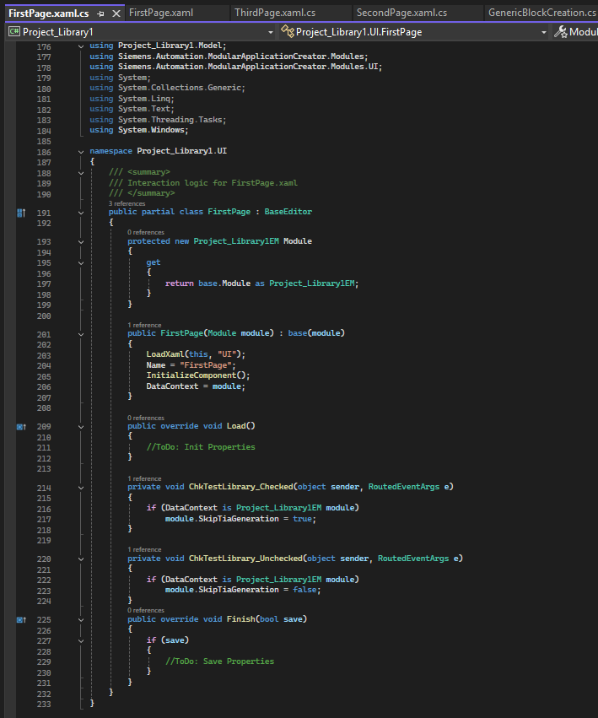
Output :-
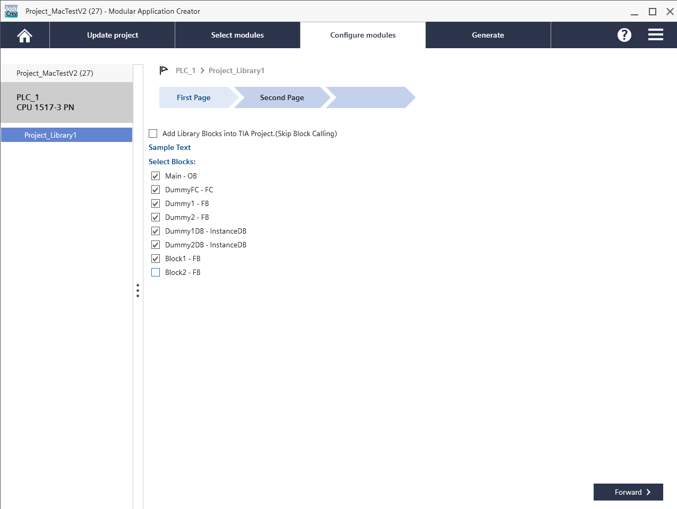
SecondPage.xaml.cs –
This code handles the functionality of the SecondPage in the TIA Portal Add-In project.
- It generates BlockTags.json files and updates PLC tag lists automatically.
- The program reads exported XML block files from TIA Portal and extracts Input, Output, InOut, and Static tags.
- Extracted tag data is stored into a Data.csv file for further processing and validation.
- It connects to TIA Portal using Openness API, opens the PLC project, compiles blocks, and exports Data Blocks recursively.
- The code also handles XML parsing, file management, and automatic export operations.
- Overall, this page automates PLC block data extraction and tag generation for efficient project handling.

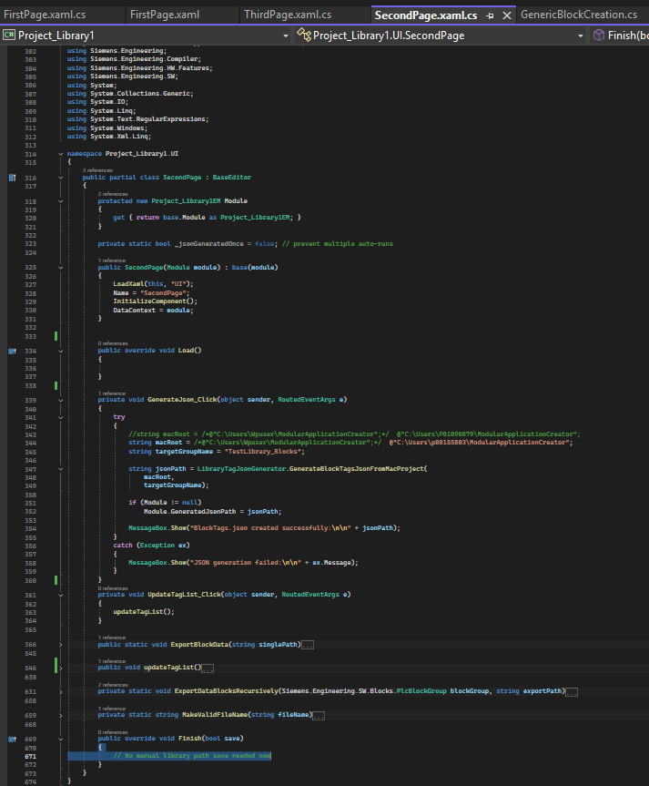

Output :-
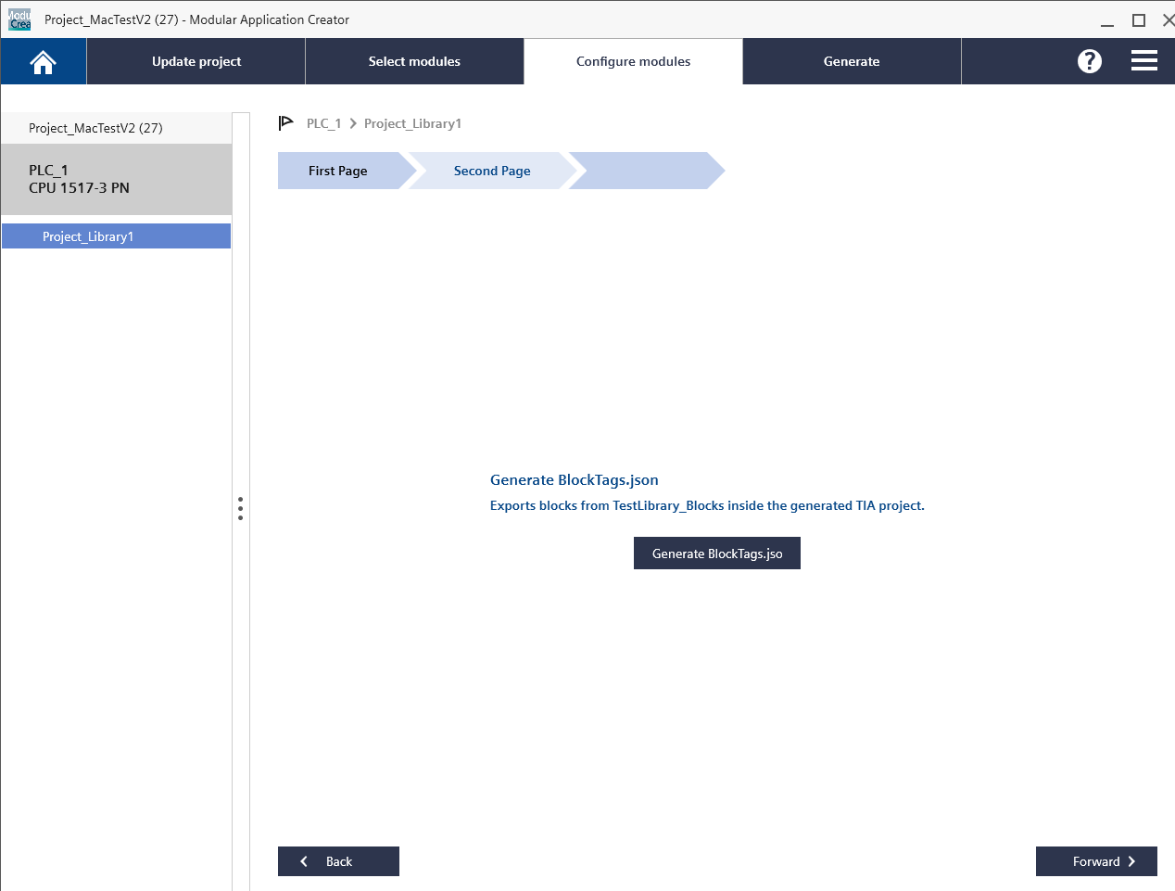
ThirdPage.xaml.cs –
This code manages the ThirdPage of the TIA Portal Add-In and handles project tree generation and block configuration.
- It creates and manages hierarchical PLC block structures using TreeView and table data.
- The code parses XML files exported from TIA Portal to identify OB, FB, FC, LAD networks, and block calls.
- It automatically generates CSV files such as FlatTable.csv, Structured.csv, ProgramBlock.csv, and Interface.csv.
- The program supports adding, updating, deleting, and loading PLC block configurations dynamically.
- Recursive XML parsing is used to detect nested block calls and generate connection relationships.
- It also extracts interface tags, network schemas, and metadata for automation and project reconstruction.
- Overall, this page automates PLC project analysis, structure generation, and CSV export for efficient TIA Portal integration.
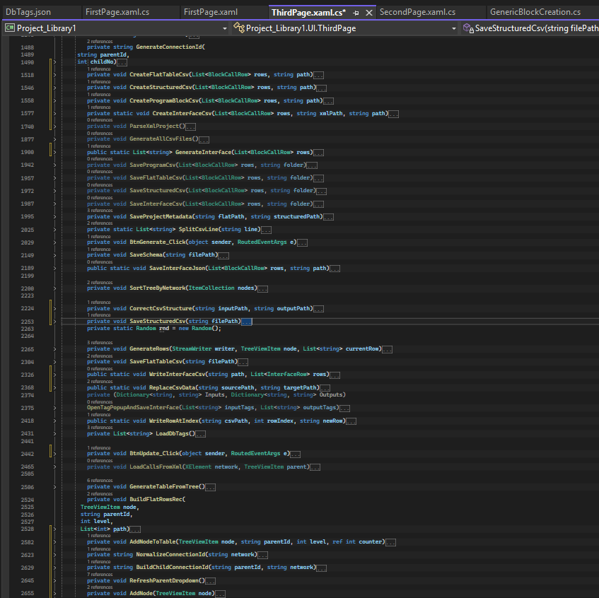
Output :-
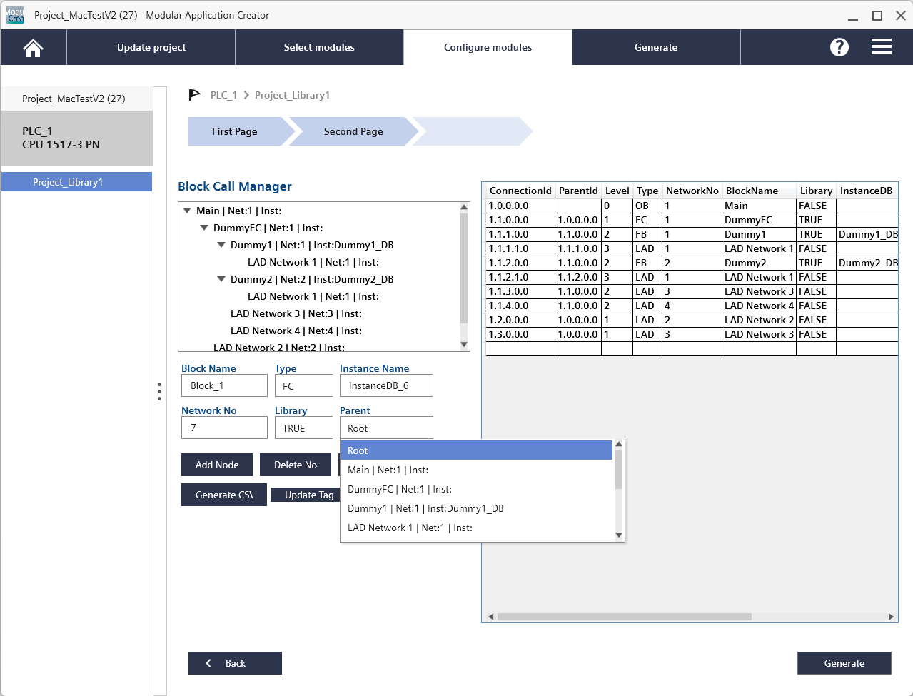
Output :- Project Generated in TIA Project


